

#### Our Motto



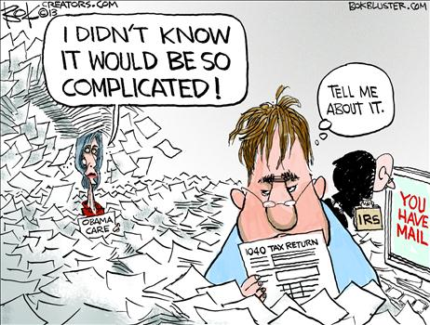

Our office is small, and we like it that way. Our size suits our philosophy: Every client is different, and every client deserves our personal attention. No one ever gets ‘lost’ or ‘misplaced’ at the LaMothe Agency. We work as a team and that means you can always contact us. Our staff is well trained, knowledgeable, and sensitive to your individual needs.

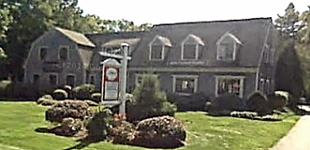 



**Call to make an appointment today!**

**1-800-649-6491**

**For all mailing,**

**mail to our main office at:**

**P.O. Box 669 East Brookfield MA 01515**

Main Office

301 East Main Street

East Brookfield, MA 01515

P (508) 867-5117

F (508) 867-5110

*Drop offs & Appointments*

Belchertown Office

175 State Street, Suite 2B

Belchertown, MA 01007

P (413) 271-7492

*Appointment Only*

Pembroke Office

50 Mattakeesett Street

Pembroke, MA 02359

P (781) 293-6645

F (781) 293-6997

*Drop offs & Appointments*

Leicester Office

1286 Main Street

Leicester, MA 01524

*Drop offs & Appointments*

**DON’T WORRY**

We Have You Covered!

**Choose One Of Our**

**Convenient Locations**

**EAST BROOKFIELD OFFICE**

**PEMBROKE OFFICE**

**BELCHERTOWN OFFICE**

**Four Locations Too Choose From!**

# Taxes ~ Financial Services Bookkeeping ~ Payroll

**For more information,**

**Check out our website at**

[**www.lamotheassoc.com**](http://www.lamotheassoc.com)

**Rachel Mcnaughtan**

FPC, Payroll Associate,

Office Manager

Ext 105

[rmcnaughtan@lamotheassoc.com](mailto:rmcnaughtan@lamotheassoc.com)

**Theresa Hutchings**

Client Write ups

Ext 302

[thutchings@lamotheassoc.com](mailto:thutchings@lamotheassoc.com)

# Robin Marble

Tax Preparer

& Notary Public

Ext 107

[rmarble@lamotheassoc.com](mailto:rmarble@lamotheassoc.com)

**Patricia Boutilette**

AFSP, Tax Preparer

& Notary Public

Ext 111

[pboutilette@lamotheassoc.com](mailto:pboutilette@lamotheassoc.com)

**Brandy Peterson**

Assistant Office Manager

**Brianna Prouty**

Tax Preparer

Ext 202

[bprouty@lamotheassoc.com](mailto:bprouty@lamotheassoc.com)

# Jennifer DeSimone

EA, MSA

Accountant

Ext 103

[jdesimone@lamotheassoc.com](mailto:jdesimone@lamotheassoc.com)

# 

**What We Can Do For You**

* Clarify your present situation by assembling all relevant personal and financial data.
* Complete your Personal or Corporate Tax Return and review how to prepare for the next tax year.
* Set up, train, and maintain your QuickBooks.
* Develop a financial plan structured to meet your needs and goals.
* Complete payroll services including Direct Deposit set up.
* Periodically review and revise your financial plan as your personal situations and economic conditions change.

#### OTHER SERVICES

# Francis LaMothe

EA, ATA, ABA, RICP®

Accountant

Ext 101

[flamothe@lamotheassoc.com](mailto:flamothe@lamotheassoc.com)

# 

#### Our Team

#### BOOKKEEPING

# Bookkeeping & Payroll Services

Bookkeeping Services

Financial Statement Preparation

Full write up services

QuickBooks Training, Setup, & Maintenance

Payroll Services

Accurate Paydays

Weekly, Monthly, & Quarterly

Direct Deposit’s

Payroll Deduction Administration

W2’s & 1099’s

Detailed Reports

# Tax Preparation & Planning

Individual Tax Preparation

Representation before Internal Revenue Service/Mass Department of Revenue

Small Business Tax Preparation

Sole Proprietorships

Partnerships

S&C Corporations

Trusts & Estates

LLC’s

Tax Planning

Projecting Estimated Tax Liabilities

Maximizing available deductions

Assisting in tax related family changes (death/divorce)

#### TAXES